TURN ON LED USING SWITCH

CIRCUIT DIAGRAM-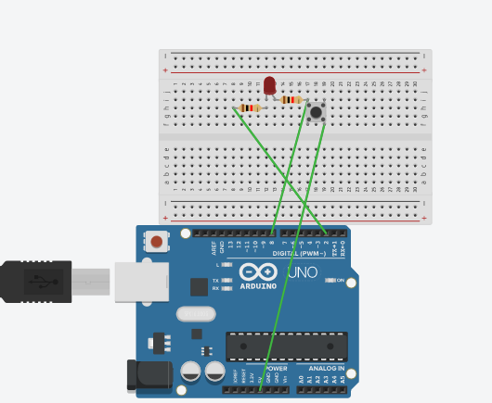

HARDWARE REQUIRED-

1.LED

2.BREADBOARD

3.ARDUINO BOARD

4.RESISTORS

5.WIRES

6.SWITCH

CONCEPT USED-

The circuit is connected in parallel.2 resistors are used connecting switch and led together on pushing then button the led turns on.

LEARNING AND OBSERVATIONS-

In this project we learnt about the use of switch.

Problems & Troubleshooting

In this project I faced many problems while connecting the circuit.

I also faced problem in doing coding for the Arduino board.

Precautions:

1.Use circuit diagram for connecting circuit on breadboard.

2. select correct pins while coding.

3. Wires Should Be Plugged into board properly.

4. Test the switch before using.

LEARNING OUTCOMES-

In this project I learnt about the use of switch.